Standing Waves

2017-02-01

Cory Wolfe

Lab Partners: Ryan Goulden and Marshall Loper

For this experiment the lab group set up an apparatus in order to represent a standing wave. The purpose of doing this is to allow the group to experiment with standing waves. The hypothesis is that increasing the frequency of the standing wave on the string will increase with the frequency of the thumper increasing. As the frequency increases the number of nodes on the wave will also increase.

This experiment required a mechanical driver, a string, a meter stick, a pulley and masses. They are set up in a way to apply tension to the string to allow for standing waves. A diagram of the apparatus is shown in Figure 1. Useful equations include:

$L=\frac{nλ}{2}$

$u=\sqrt{\frac{T}{μ}}$

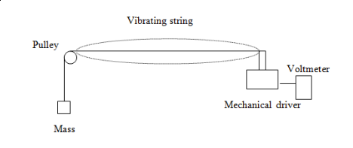  
Figure 1: Diagram of Lab Setup

The procedure for this experiment involved setting up the apparatus as shown in Figure 1. After this was done power was applied to the thumper at a frequency that allowed for a standing wave with one anti-node. The frequency was recorded and then the frequency was increased in order to increment the number of nodes from three to four and then five. After this was completed the velocity was calculated using the tension on the string and the mass per length of the string. Then the data was recorded.

After this was completed the experiment was repeated with an additional thirty gram mass causing tension on the spring. The data collected in these experiments is available in Figure 2.

|  |  |  |  |  |  |
| --- | --- | --- | --- | --- | --- |
| L = 1 m | 1 Freq(Hz) | 2 Freq(Hz) | 3Freq(Hz) | 4 Freq(Hz) | Velocity(m/s) |
| 30 grams | 15 | 35 | 55 | 76 | 1.27 |
| 60 grams | 22.5 | 52.5 | 82.5 | 112.5 | 1.808 |

Figure 2: Table of Data

For this lab the group found that the increase in frequency followed a linear relationship, while not being simply multiplicable. When touching the node the string continued to vibrate, whereas the anti-nodes stopped the vibration, due to the fact that touching the string at the node would cause the vibration to stop. When the additional mass was added it caused some changes in the system. The velocity of the wave with additional mass increased, which makes sense because additional energy would be required. The thumper motor was counted as a node for this experiment while it may not truly be, because it creates movement , and thus does not stand still as a true node would.